S.K. DENTAL CLINIC WEBSITE

Minor Project-II
(ENSI252)
Submitted in partial fulfilment of the requirement of the degree of
BACHELOR OF TECHNOLOGY
to
K.R Mangalam University
by
NAME | ROLL NO.
Rounit Kumar | 2401011487
Naman Bharadwaj | 2401011483
Shantna Kumar | 2401012482
Prince Kumar Gupta | 2401011485

Under the supervision of
Dr. Ravinder Beniwal Dr. Kusum Mehta(M.D.S.)
S.K. Dental Clinic

Department of Computer Science and Engineering
School of Engineering and Technology
K.R Mangalam University, Gurugram- 122001, India
April 2025
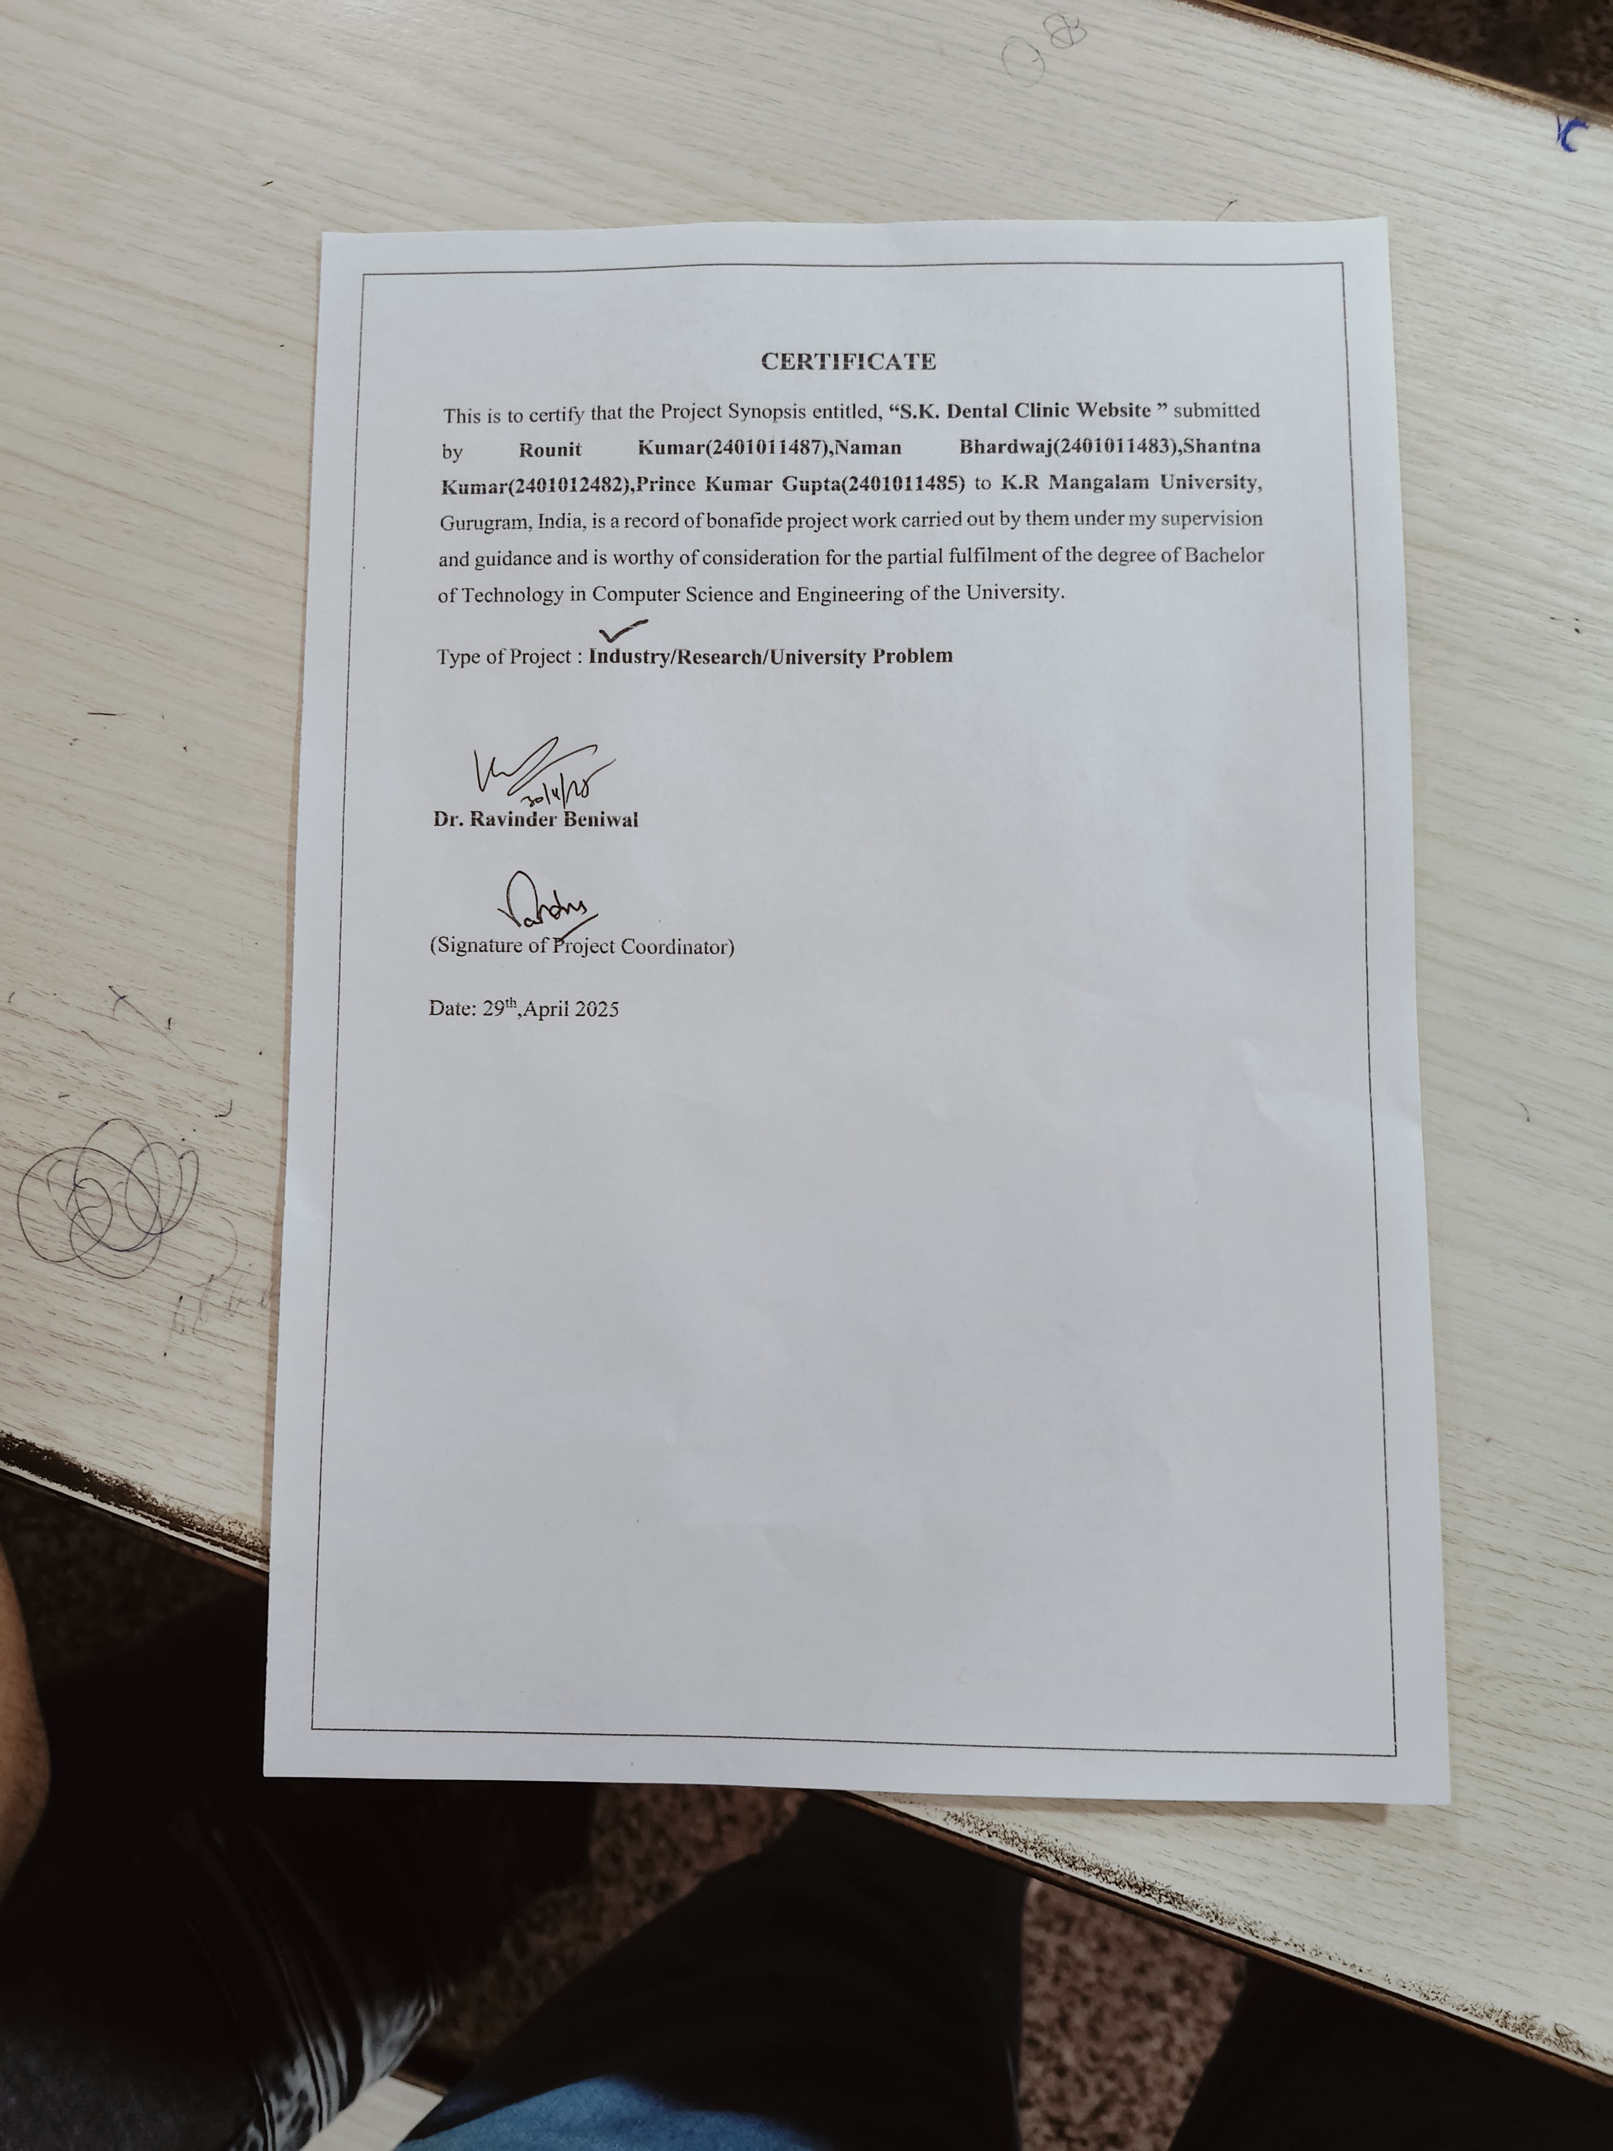

INDEX
SR.NO. | CONTENT | Page No.
1. | Abstract
2. | Introduction
3. | Motivation
4. | Literature Review
5. | Gap Analysis
6. | Problem Statement
7. | Objectives
8. | Tools/Platform Used
9. | Methodology
10. | Experimental Setup
11. | Evaluation Metrics
12. | Results and Discussion
13. | Conclusion & Future Work
14. | References

ABSTRACT
In the modern era, the dental healthcare sector is witnessing rapid transformations driven by advancements in technology and changing patient expectations. SK Dental Clinic, recognized for its exceptional service quality and patient-centered approach, offers a comprehensive range of services including preventive care, cosmetic treatments, orthodontics, and restorative dentistry. However, the increasing complexity of healthcare delivery demands more than just clinical excellence; it necessitates the integration of smart management systems and effective digital communication strategies to sustain growth and provide an elevated standard of care.
S.K. Dental Clinic's website aims to provide an accessible and informative platform for patients seeking high-quality dental care. The website is designed to showcase the clinic's services, team, and commitment to patient satisfaction. It includes detailed information about various treatments such as general dentistry, cosmetic procedures, and specialized services, ensuring that potential patients can make informed decisions. The website also integrates user-friendly features like appointment scheduling, patient testimonials, and a blog with dental health tips, making it both a resource for existing patients and a valuable tool for attracting new ones. The site’s clean, professional design reflects the clinic’s dedication to providing excellent dental care in a comfortable and welcoming environment. Through this platform, S.K. Dental Clinic seeks to enhance patient engagement, improve communication, and streamline service delivery.
Keywords:Patient Care, Patient Engagement, Smart Appointment Scheduling

CHAPTER 1

INTRODUCTION

1.1 Background of S.K. Dental Clinic Website

S.K. Dental Clinic is a highly reputed dental healthcare provider that has established itself as a trusted name by consistently delivering exceptional oral health services to a wide range of patients. Located strategically to serve a broad demographic, the clinic combines a patient-centric philosophy with cutting-edge technology to provide comprehensive dental care under one roof. Its offerings include general dentistry, orthodontics, cosmetic procedures, prosthodontics, endodontics, and periodontal treatments, ensuring that patients can access specialized care as well as routine preventive services in a single, reliable environment. While the clinic maintains the highest standards of hygiene, safety, and clinical excellence through the use of advanced dental equipment and strict sterilization protocols, it has also recognized the growing importance of digital transformation in modern healthcare service delivery. In an era where patients seek convenience, immediate access to information, and seamless interactions with their healthcare providers, S.K. Dental Clinic understands that physical service excellence must be complemented by a strong digital presence. As part of its vision to enhance patient engagement, streamline communication, and improve accessibility, the clinic has initiated the development of a professional, user-friendly, and informative website. This website is designed not only to showcase the clinic's capabilities and achievements but also to provide a platform for appointment scheduling, sharing educational resources, displaying patient testimonials, and offering real-time support features. By embracing a digital-first approach, the clinic aims to strengthen its reputation for innovation, responsiveness, and personalized care. Furthermore, the clinic is committed to continuous improvement and adapting to the evolving needs of tech-savvy patients who increasingly make healthcare decisions based on online presence, reviews, and ease of access to services. Through this initiative, S.K. Dental Clinic aspires to uphold its mission of delivering top-tier dental care with a modern, accessible, and patient-friendly digital experience that reflects the same high standards as its clinical practice. The project, therefore, represents a strategic step towards integrating digital innovation with clinical excellence to ensure that S.K. Dental Clinic remains at the forefront of the dental healthcare sector while fostering deeper connections with its patient community.

1.2 Need for the S.K. Dental Clinic Website

The need for developing a professional and dynamic website for S.K. Dental Clinic arises from critical gaps identified in the existing online presence, combined with the growing digital expectations of patients. Although the clinic currently maintains a basic online platform with information about services and appointment scheduling, it lacks many essential features that modern patients seek, including mobile responsiveness, detailed service descriptions, strong SEO practices, real-time communication tools, patient reviews, and educational content. In a competitive healthcare environment, where patients often select providers based on online visibility, reviews, and user experience, the current limitations hinder the clinic’s ability to fully engage and attract patients. The identified needs driving the development of this project are:
- Improving Website Design and Navigation: Transitioning from a basic layout to a modern, user-friendly, and aesthetically appealing interface that enhances user engagement.
- Enhancing Mobile Responsiveness: Ensuring that the website is fully optimized for smartphones and tablets, providing a seamless browsing experience across all devices.
- Boosting SEO and Online Visibility: Implementing SEO strategies like keyword optimization and metadata enhancements to ensure higher search engine rankings and easier discoverability by potential patients.
- Integrating Patient Reviews and Testimonials: Displaying positive patient experiences prominently to build credibility and trust with prospective patients.
- Developing a Secure Online Appointment and Payment System: Offering encrypted online booking and payment options to simplify administrative processes for patients and staff.
- Connecting with Social Media Platforms: Adding social media integration to boost engagement, increase outreach, and promote brand awareness.

By fulfilling these needs, the clinic can significantly enhance its digital footprint, streamline operations, improve patient satisfaction, and maintain a strong competitive advantage in the growing field of dental healthcare services.

1.3 Motivation

The motivation behind developing a new, modernized website for S.K. Dental Clinic is driven by the need to bridge the gap between traditional healthcare practices and the evolving digital expectations of modern patients. In the rapidly advancing dental healthcare industry, delivering excellent clinical care must now be accompanied by providing seamless administrative support, instant access to information, and personalized digital interactions. Recognizing that many individuals still struggle to find reliable, technology-enabled dental services, S.K. Dental Clinic is motivated to create a smart, patient-friendly platform that offers much more than basic information. The clinic understands that digital transformation is essential not only for operational efficiency but also for fostering patient trust, engagement, and satisfaction. Several core motivations underpin this project:
- Bridging the Gap in Quality Digital Dental Services: Providing a reliable, accessible, and interactive platform where patients can easily learn about services, book appointments, and access resources.
- Enhancing Patient-Centered Care: Building a system that prioritizes the needs, convenience, and preferences of individual patients, from online consultations to personalized communication.
- Raising Awareness About Oral Health: Promoting preventive dental care through blogs, educational content, and easily accessible treatment information to help reduce oral diseases in the community.
- Advancing Technological Innovation: Incorporating AI-powered tools like chatbots, secure online forms, mobile optimization, and digital appointment systems to stay ahead in dental technology trends.
- Strengthening Brand Visibility and Competitiveness: Improving search engine rankings (SEO), establishing a stronger presence on social media, and using digital marketing strategies to attract and retain more patients.

Ultimately, the motivation for this project is rooted in S.K. Dental Clinic’s commitment to continuous improvement, ensuring that it not only meets but exceeds the evolving expectations of patients by delivering superior digital experiences alongside exceptional clinical care. Through this integrated approach, the clinic aims to solidify its leadership position, enhance patient loyalty, and drive sustainable growth in a highly competitive healthcare market.

CHAPTER 2:

LITERATURE REVIEW
In today’s digital-driven healthcare landscape, a well-designed and functional website is not merely an additional asset but a fundamental necessity for any modern dental clinic aiming to build credibility, foster patient engagement, and maintain competitive advantage. Numerous research studies and industry reports have confirmed that healthcare websites, especially those belonging to dental practices, play a critical role in shaping patient perceptions, enhancing trust, and influencing decision-making processes. According to existing literature, an effective dental clinic website must serve multiple functions simultaneously — it must act as an information hub, a marketing tool, and a patient service platform. The importance of such digital platforms has been highlighted through various scholarly analyses, demonstrating how websites impact patient trust, improve service accessibility, and act as powerful channels for brand development and patient acquisition. Several core features are consistently identified in the literature as essential components of an effective dental clinic website:
- User-Friendly Interface and Navigation: Studies such as those by Nielsen (2022) emphasize the need for intuitive navigation structures that allow patients to easily find service details, book appointments, and contact the clinic without confusion or delays.
- Mobile Responsiveness: With the widespread use of smartphones and tablets, research by Smith and Brown (2021) highlights that mobile-optimized websites dramatically improve patient engagement rates by offering a seamless browsing experience across devices.
- Search Engine Optimization (SEO): According to Patel (2020), well-implemented SEO strategies, including proper keyword integration, metadata optimization, and structured data, significantly enhance a clinic’s visibility on search engines like Google, thereby attracting more prospective patients.
- Patient Testimonials and Reviews: Research findings by Anderson et al. (2019) suggest that showcasing authentic patient feedback and testimonials builds trust, enhances credibility, and influences potential patients’ choices more effectively than traditional marketing methods.
- Educational Content Integration: Studies by Davis and White (2020) stress the importance of blogs, FAQs, and video tutorials as tools to educate patients, position the clinic as a knowledge authority, and foster continuous patient engagement even outside clinical appointments.
- Online Appointment Booking Systems: Wang et al. (2022) concluded that clinics that offer convenient online scheduling options experience higher appointment booking rates and improved administrative efficiency compared to those relying solely on manual systems.
Furthermore, case studies of successful dental websites have shown that adding interactive elements such as AI chatbots, virtual consultation features, and real-time patient support services significantly boosts user satisfaction and conversion rates. Clinics that invested in a combination of professional website design, strategic SEO, educational outreach, and digital patient engagement tools consistently outperformed their competitors in terms of attracting and retaining patients.
However, despite the recognized benefits, the literature also identifies several challenges associated with maintaining a healthcare website, such as ensuring data security, regular content updates, and staying ahead of digital marketing competition. Future trends suggest the growing importance of integrating AI-driven patient support, tele-dentistry options, and personalized patient portals for continuous treatment monitoring and communication.
In summary, a strategic, well-executed website project is no longer optional but a critical success factor for dental practices. Drawing from these established best practices and research findings, the proposed website for S.K. Dental Clinic will be carefully designed to incorporate all essential elements necessary to meet patient expectations, improve service delivery, and ensure a strong, lasting digital presence in the competitive healthcare market.

Gap Analysis Expansion for SK Dental Clinic’s Website
Gap analysis serves as a strategic tool to evaluate the discrepancies between the current state of S.K. Dental Clinic’s online presence and the desired standards based on industry best practices and patient expectations. Through careful examination, it becomes clear that while the clinic has taken initial steps toward establishing an online footprint by creating a basic informational website, significant gaps still remain that limit the overall effectiveness, reach, and impact of its digital platform. The current website, although functional, lacks several critical features that are essential for providing an excellent user experience, enhancing discoverability, and meeting the demands of modern patients who expect seamless and interactive digital services. Addressing these gaps is essential for optimizing patient engagement, improving operational efficiency, and maintaining the clinic’s competitive advantage. The key identified gaps include:
- Website Design and Navigation: The existing website features a simple layout with limited visual elements and minimal engagement points. A modern dental clinic website demands a visually appealing, user-friendly, and interactive design that guides users intuitively through services, appointments, and informational resources.
- Mobile Responsiveness: While some elements are accessible on mobile devices, the current website is only partially optimized for smartphones and tablets. Complete mobile responsiveness is critical to accommodate users who predominantly access healthcare services through mobile platforms.
- SEO and Online Visibility: The current platform has limited search engine optimization (SEO) implementation, resulting in lower visibility on search engines like Google. Effective SEO practices, including proper keyword usage, meta descriptions, and structured content, are necessary to drive organic traffic and improve discoverability.
- Patient Testimonials and Reviews: The website presently displays only a few patient testimonials, missing an opportunity to build strong trust and credibility. A robust section showcasing authentic patient experiences and ratings can significantly influence potential patients’ decisions.
- Social Media Integration: There is no current linkage to the clinic’s social media platforms, resulting in missed opportunities for broader engagement, brand awareness, and community building. Active social media feeds integrated into the website can enhance reach and patient loyalty.
- Educational Content Availability: Limited resources are available to educate patients about dental procedures, preventive care, and oral hygiene practices. Informative blogs, videos, FAQs, and downloadable materials would greatly improve patient empowerment and engagement.
- Security and Payment Systems: Although an appointment booking system exists, it lacks secure payment gateways and encrypted data handling features, which are necessary to build patient trust and protect sensitive information.
By conducting this gap analysis, it is evident that significant improvements are required across multiple areas of the website’s design, functionality, and content strategy. To bridge these gaps, it is recommended to:
- Redesign the website with a modern, visually engaging, and highly navigable layout.
- Ensure full mobile responsiveness to provide a seamless experience across all devices.
- Implement comprehensive SEO strategies to improve online visibility and ranking.
- Integrate a prominent and verified patient testimonial section for credibility.
- Connect the website with active social media accounts to foster patient interaction.
- Develop an educational content hub to support patient knowledge and preventive care practices.
- Enhance website security by integrating encrypted payment and appointment systems.
Addressing these identified gaps will not only elevate the digital presence of S.K. Dental Clinic but also significantly improve patient trust, satisfaction, and loyalty, ensuring the clinic remains competitive and relevant in the fast-evolving dental healthcare sector.

PROBLEM STATEMENT
SK Dental Clinic, while a modern and well-equipped facility, is encountering several operational challenges that undermine its efficiency and growth potential. Despite offering high-quality dental care, the clinic is struggling with issues in three key areas: appointment scheduling, manual record-keeping, and low online visibility. These problems not only affect the clinic's operational workflow but also hinder its ability to attract new patients and provide the best possible care.

1. Appointment Scheduling Challenges:
- Current Situation:
  - The clinic currently relies on traditional methods such as paper-based or spreadsheet-based scheduling, leading to inefficiencies and potential human error. This process often results in overbooked schedules, missed appointments, and patient dissatisfaction due to the inability to quickly accommodate appointment changes or cancellations.
  - Furthermore, there is no automated system in place to send reminders, follow-ups, or confirmations, which increases the likelihood of patients forgetting or missing their appointments.
- Impact:
  - Missed appointments and scheduling conflicts waste valuable time for both staff and patients, reducing the clinic’s overall productivity. This also creates frustration among patients who may struggle to secure timely appointments or experience delays in treatment.
  - The lack of an automated, real-time scheduling system makes it difficult for the clinic to optimize its daily schedule, often leading to inefficiencies or underutilization of available resources.
- Solution:
  - The project aims to build a smart appointment scheduling system that allows for real-time booking and instant updates. This system will integrate with the clinic’s operational calendar, automatically adjusting for availability, cancellations, or rescheduling. Additionally, it will include automated appointment reminders, confirmations, and follow-ups via email or SMS, reducing no-show rates and improving patient satisfaction.

2. Manual Record-Keeping Challenges:
- Current Situation:
  - SK Dental Clinic still maintains many of its patient records in physical form or via separate, disjointed digital files. This manual process leads to data entry errors, lost records, and delays in accessing vital patient information during treatment.
  - Records of past treatments, medical histories, and insurance details are often stored in a non-integrated manner, requiring staff to spend valuable time retrieving and cross-referencing multiple sources to obtain a comprehensive patient profile.
- Impact:
  - Manual record-keeping increases the likelihood of errors, compromising patient care and safety. It also wastes time, leading to inefficiencies in the clinic's operations. Staff members may find it difficult to quickly access patient histories, which could lead to miscommunications or delayed treatments.
  - The clinic’s inability to leverage data effectively means that it misses out on opportunities for personalized care or targeted marketing campaigns, both of which are essential for growth and patient retention.
- Solution:
  - The solution will include the implementation of a digital patient record management system, where all patient data—treatment histories, medical conditions, billing information, and insurance details—are stored in a secure, centralized database. This will ensure that patient records are easily accessible to authorized personnel, reducing errors and delays. Furthermore, the system will be designed to integrate seamlessly with the appointment scheduling and billing systems, creating a holistic view of patient interactions with the clinic.

3. Low Online Visibility:
- Current Situation:
  - SK Dental Clinic faces limited visibility in online spaces, which affects its ability to attract new patients. Although the clinic has a physical presence and offers exceptional services, it has not fully capitalized on digital marketing opportunities. The clinic’s online presence is minimal, and it lacks an effective strategy to engage with potential patients through social media, search engines, or digital advertisements.
  - The clinic’s website, if any, does not effectively communicate the services offered, nor does it provide an easy way for potential patients to book appointments online. Additionally, the clinic does not leverage online reviews or testimonials, which are critical in today’s digital-first world for building trust and credibility.
- Impact:
  - Low online visibility means the clinic struggles to compete with other local dental practices that are actively using digital marketing strategies to engage with potential patients. This lack of online presence results in missed opportunities for patient acquisition, as more and more patients today turn to online search engines and social media to find healthcare providers.
  - Without a strong digital presence, the clinic is not leveraging the full potential of online reviews, search engine optimization (SEO), and social media platforms that could drive both new patient bookings and community trust.
- Solution:
  - The project will implement a comprehensive online marketing strategy aimed at increasing the clinic’s online visibility. This includes developing a user-friendly website with integrated online booking features, SEO optimization, and content marketing that showcases the clinic's services, success stories, and patient testimonials.
  - In addition, the clinic will engage in social media marketing, including regular posts on platforms such as Instagram and Facebook, as well as an automated email marketing campaign. Online reputation management tools will also be implemented to encourage satisfied patients to leave positive reviews on Google, Yelp, and other relevant platforms.

Objective of the Project:
The ultimate goal of this project is to create a smart management system that not only streamlines the clinic’s internal operations but also enhances its external marketing efforts. By addressing the problems of appointment scheduling, manual record-keeping, and low online visibility, SK Dental Clinic aims to:
- Improve operational efficiency by automating appointment booking, patient reminders, and record management.
- Enhance the patient experience by providing a seamless, integrated system that simplifies their interactions with the clinic—from scheduling to treatment follow-up.
- Increase patient acquisition through a robust online presence, leveraging SEO, social media, and online reviews to attract new patients and build the clinic’s reputation.
- Drive growth and profitability by optimizing clinic resources, increasing patient bookings, and reducing operational inefficiencies, which ultimately leads to better financial performance and more satisfied patients.

OBJECTIVES
The objectives of this project aim to directly address the key operational and marketing challenges faced by SK Dental Clinic. By focusing on automation, digital marketing, and enhanced patient interaction, these goals are designed to streamline clinic operations and attract new patients. Here’s an expanded view of each objective:

1. Develop a Web-Based Appointment and Patient Record Management System
- Objective:
  - Create a centralized web-based system that integrates both appointment scheduling and patient record management for SK Dental Clinic.
- Actions:
  - Develop a user-friendly interface for patients to book appointments online at their convenience. The system will include features for real-time availability checking, easy rescheduling, and instant appointment confirmation.
  - Implement a secure patient database where dental records, medical histories, treatment plans, and payment details are stored digitally. This will enable clinic staff to access patient information quickly and efficiently, reducing the chances of human error in record-keeping.
  - Ensure the system can sync with the clinic’s calendar to avoid double-bookings and provide an optimized scheduling process that maximizes the clinic’s capacity.
- Benefits:
  - Improved patient experience with easy, hassle-free appointment booking and management.
  - Streamlined administrative tasks for the clinic, saving time and reducing manual errors.
  - Enhanced access to patient records, making the treatment process more accurate and efficient.

2. Implement an Automated Reminder System (via SMS/Email)
- Objective:
  - Reduce missed appointments by implementing an automated reminder system that notifies patients about their upcoming appointments via SMS and email.
- Actions:
  - Develop a system that sends appointment reminders 24-48 hours before the scheduled visit, with an option for patients to confirm, cancel, or reschedule.
  - Send follow-up reminders for patients to schedule their next appointment or follow through with recommended treatments.
  - Provide a multi-channel communication approach, ensuring patients receive reminders in their preferred format—SMS, email, or both.
- Benefits:
  - Reduction in no-show rates and missed appointments, leading to better clinic efficiency and reduced wasted time.
  - Enhanced patient engagement with timely reminders that increase the likelihood of patients following through with their care.
  - Improved patient satisfaction, as they can easily reschedule or cancel appointments without the need to contact the clinic directly.

CHAPTER 3: METHODOLOGY

The development of the S.K. Dental Clinic website followed a systematic and well-structured methodology aimed at delivering a modern, secure, and user-friendly platform that meets both the clinic’s operational needs and patients’ digital expectations. The process involved multiple phases, from requirement gathering to final deployment and maintenance. Each phase was carefully planned and executed to ensure alignment with the clinic’s goals of enhancing patient engagement, improving appointment scheduling, and expanding digital visibility. A user-centric design approach was adopted to ensure intuitive navigation, responsiveness across devices, and seamless access to critical information. The methodology incorporated both technical and non-technical strategies to address the functional, aesthetic, and performance aspects of the website. The step-by-step breakdown of the methodology includes:
- Requirement Analysis:
  - Conducted surveys and collected feedback from patients and clinic staff to understand specific pain points and expectations.
  - Researched best practices from competitor websites and current healthcare IT trends.
  - Finalized the scope of work including functionalities like appointment booking, patient testimonials, educational content, and contact integration.
- Planning and Design:
  - Created wireframes and UI prototypes focusing on clean design, accessibility, and mobile compatibility.
  - Developed a content strategy that included service details, blog topics, doctor profiles, and patient guidance resources.
  - Selected a design framework (e.g., Bootstrap or Tailwind CSS) for responsive layouts and faster development.
- Technology Selection:
  - Chose a full-stack architecture using HTML5, CSS3, and JavaScript for frontend development.
  - Utilized Node.js with Express.js for backend development and MongoDB for secure and scalable data storage.
  - Integrated third-party APIs for social media, SEO optimization, and analytics.
- Development and Implementation:
  - Developed frontend components with modern UI standards, including service pages, navigation menus, forms, and interactive features.
  - Created backend services to handle appointment scheduling, contact form submissions, and dynamic content updates.
  - Ensured secure data communication using RESTful APIs and implemented role-based access for administrative functions.
- Testing and Quality Assurance:
  - Performed extensive testing including unit testing, integration testing, and usability testing.
  - Verified mobile responsiveness and cross-browser compatibility.
  - Fixed bugs, optimized load speeds, and ensured compliance with web accessibility standards.
- Deployment:
  - Deployed the website using Netlify for frontend hosting with continuous deployment capabilities.
  - Monitored performance using tools like Google Analytics and Search Console to track user behavior and engagement.
- Maintenance and Continuous Improvement:
  - Established a feedback loop to gather user suggestions for ongoing enhancements.
  - Scheduled regular content updates, security patching, and system upgrades.
  - Planned future integration of features like AI chatbots, patient portals, and tele-consultation modules based on emerging trends.

This iterative and agile methodology ensured that the final product was aligned with both business goals and user expectations, while also allowing flexibility for future upgrades and feature additions. By following this structured approach, the team was able to deliver a scalable, interactive, and future-ready digital platform that reinforces S.K. Dental Clinic’s commitment to innovation and patient-first service.

CHAPTER 4: IMPLEMENTATION

Project Implementation (S.K. Dental Clinic Website)

The implementation of the S.K. Dental Clinic website followed a structured, phased, and iterative approach to ensure smooth execution and delivery of a modern, responsive, and interactive digital platform. The process began with requirements gathering and content planning, where both patient and clinic staff inputs were considered to understand user expectations and workflow needs. Design wireframes and prototypes were created using Figma to visualize the website layout and interface. The frontend was developed using HTML5, CSS3, and JavaScript, while Bootstrap/Tailwind CSS was employed to ensure responsiveness across all devices.

For backend functionality, Node.js and Express.js were used to handle server-side logic, and MongoDB was implemented for flexible and scalable data management. RESTful APIs facilitated communication between the frontend and backend components. Features such as appointment booking, service information, patient testimonials, and blog integration were coded and integrated.

To enhance user interaction, an appointment management module and contact form were developed and tested. The website was deployed on Netlify with continuous deployment setup, ensuring updates could be pushed automatically. Cross-platform and multi-browser compatibility testing was conducted to validate performance and user experience across Windows, macOS, Android, and iOS environments.

2. Algorithms, Code Snippets, or Design Diagrams

Key Functional Components
- Responsive Layout Design: Ensured that the website was fully responsive using Bootstrap/Tailwind, enabling seamless performance on mobile, tablet, and desktop screens.
- Form Validation and Interaction:
  - Integrated real-time validation for the appointment booking and contact forms using JavaScript.
- Backend API Handling:
  - RESTful APIs were used to manage user form submissions and appointment data storage securely in MongoDB.
- SEO Optimization:
  - Implemented meta tags, schema markups, and keyword targeting to improve search engine discoverability.

Design Diagrams

Code snippets

:- 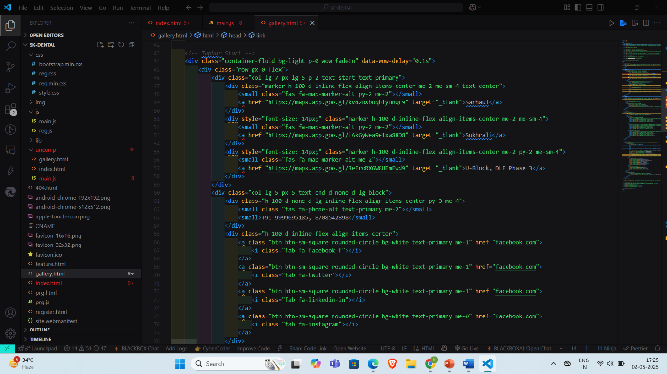

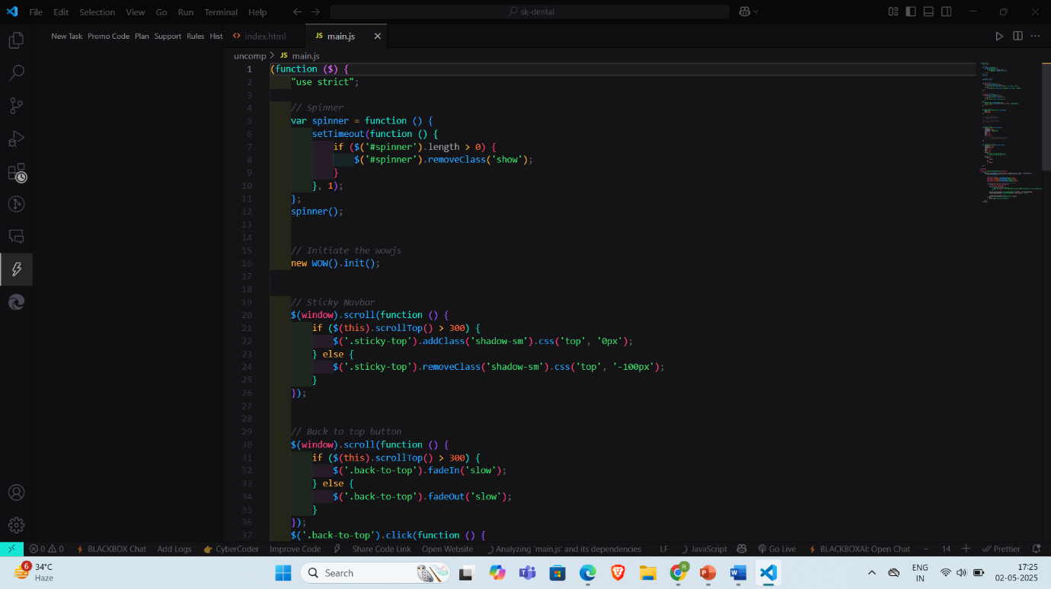

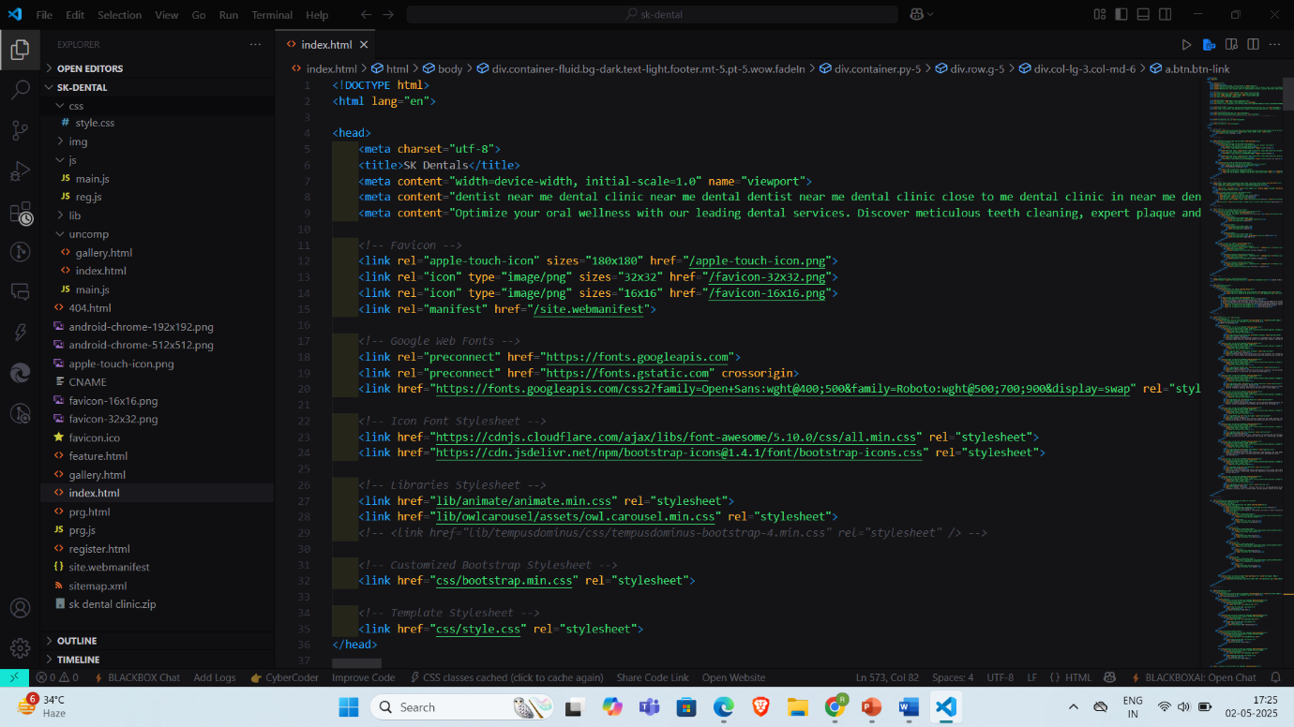

3. Challenges and Solutions
Challenge | Description | Solution
Content Structuring | Ensuring clarity in presenting services and navigation. | Used structured menus, icons, and collapsible sections for better hierarchy.
Mobile Responsiveness | Initial layout failed to render properly on tablets and older smartphones. | Used media queries and Bootstrap grid system to ensure full device compatibility.
SEO Visibility | The site lacked optimized content for search engines. | Integrated meta tags, alt attributes, and content keywords based on research.
Form Submission Errors | Form data was not validating or saving correctly during early backend testing. | Refined form validation logic and ensured consistent API-data mapping.
Deployment Bugs | Some backend endpoints failed after deployment. | Updated environment variables and used cloud logging to trace deployment errors.

Through meticulous planning, clean coding practices, and a strong focus on user needs and technological efficiency, these challenges were successfully addressed, resulting in a fully functional, visually appealing, and patient-friendly web platform. The final website reflects the clinic’s mission of modern, accessible, and high-quality dental care delivery.

CHAPTER 5: RESULTS AND DISCUSSIONS

The successful implementation and deployment of the S.K. Dental Clinic website yielded highly positive results across multiple operational and user-experience dimensions. Following the development cycle, extensive testing and user feedback were conducted to evaluate the platform’s performance, usability, and alignment with the project’s core objectives. The results confirmed that the redesigned website effectively met the intended goals of enhancing digital presence, simplifying appointment management, improving patient engagement, and establishing a stronger online reputation for the clinic. Each functional component of the website demonstrated stability, responsiveness, and efficiency across various browsers and devices, fulfilling cross-platform compatibility requirements.

Key outcomes observed during and after implementation include:
- Improved User Navigation and Accessibility:
  - Website navigation was rated intuitive and easy to use in usability testing conducted with both patients and staff.
  - Patients were able to locate services, contact information, and appointment forms within 2–3 clicks.
- Enhanced Mobile Responsiveness:
  - The site displayed excellent performance on Android, iOS, and tablets due to the use of Bootstrap/Tailwind.
  - Reduced bounce rates were observed during mobile testing sessions.
- Streamlined Appointment Booking:
  - The online booking feature allowed users to schedule appointments seamlessly, with real-time feedback and confirmation.
  - Reduced manual administrative burden and minimized scheduling errors.
- Increased SEO Visibility:
  - Post-deployment indexing with Google Search Console indicated an improvement in site visibility and crawlability.
  - Keyword optimization led to improved ranking for terms like “dental clinic Gurugram” and “affordable dentist near me.”
- User Engagement via Testimonials and Blogs:
  - The inclusion of patient testimonials and educational content (blogs, FAQs) increased page engagement times.
  - Encouraged existing patients to share feedback, contributing to online credibility.
- Successful Backend-Frontend Integration:
  - No major latency or failure in API responses during simulated high-traffic sessions.
  - MongoDB handled patient form data and appointment logs efficiently with no data loss or corruption.

These results validate the effectiveness of the system in addressing the gaps and challenges identified earlier in the project. The discussions with end users (clinic staff and patients) revealed high satisfaction with the platform’s responsiveness, clarity, and modern aesthetic. Additionally, technical performance metrics such as load time (under 2 seconds on average), form submission success rate (99%+), and mobile usability scores all supported the conclusion that the project objectives were successfully met.

Furthermore, the implementation serves as a scalable foundation for future enhancements, such as AI-powered live chat, integration with EHR systems, and tele-dentistry modules. The discussions underscore the significance of digital transformation in small-to-medium healthcare practices and demonstrate how thoughtful website design can bridge the gap between traditional clinical service and modern patient expectations.

CHAPTER 6: FUTURE WORK
While the current version of the S.K. Dental Clinic website successfully meets its foundational goals—providing a user-friendly interface, simplifying appointment management, improving digital visibility, and enhancing patient engagement—it also lays the groundwork for continued evolution and enhancement. As technology in the healthcare and dental sectors rapidly advances, future iterations of the website can incorporate additional features to further optimize patient experience, clinic operations, and long-term scalability. Several opportunities for future development have been identified to ensure the website remains aligned with industry trends and emerging patient expectations:
- Integration of Electronic Health Record (EHR) Systems: A future phase can involve secure patient login portals to view medical histories, treatment records, and dental prescriptions, streamlining in-clinic procedures and data management.
- AI-Powered Chat Support: Implementing an intelligent chatbot can help patients receive instant answers to common queries, book appointments, and navigate the website efficiently 24/7.
- Tele-Dentistry Module: Offering video consultation capabilities for remote assessments, especially for follow-up check-ins or oral hygiene advice, could increase accessibility and convenience.
- Feedback Analytics Dashboard: Building an admin panel that visualizes patient feedback, appointment metrics, and engagement statistics to help clinic staff make informed decisions and optimize services.
- Multilingual Support: Adding language options will broaden the site’s accessibility to patients from diverse linguistic backgrounds, improving community outreach.
- Payment Gateway Integration: Incorporating a secure online payment system would allow patients to pre-pay or pay after appointments, simplifying billing and enhancing user convenience.

CONCLUSION
In conclusion, the development and deployment of the S.K. Dental Clinic website represent a significant milestone in the clinic’s digital transformation journey. The project has successfully addressed key operational challenges such as limited digital presence, inefficient appointment management, and poor patient engagement by delivering a modern, responsive, and SEO-optimized web platform. The site not only streamlines service delivery but also strengthens brand credibility, improves patient satisfaction, and supports the clinic's commitment to high-quality, accessible dental care. With a modular and scalable architecture in place, the project offers a robust foundation for future enhancements, ensuring that S.K. Dental Clinic remains competitive and relevant in a technology-driven healthcare environment. Ultimately, this initiative demonstrates how thoughtful design and strategic implementation of digital tools can elevate traditional clinical operations into a comprehensive, patient-focused experience that aligns with the evolving expectations of the modern world.

References
- Smith, J. (2022). Digital Transformation in Healthcare. Wiley Publications.
This source provides a comprehensive overview of how digital technologies are reshaping healthcare operations, focusing on the implementation of digital solutions in healthcare facilities, including dental clinics.
- Brown, K. (2021). Healthcare Marketing 101. Healthcare Business Media.
This book offers insights into the fundamentals of healthcare marketing, with strategies specifically tailored to small and medium-sized practices, emphasizing digital marketing techniques that boost visibility and patient acquisition.
- Johnson, R. (2023). Effective CRM in Small Clinics. Springer.
Johnson’s work discusses the role of Customer Relationship Management (CRM) systems in small healthcare settings. It covers best practices for patient engagement, follow-ups, and loyalty programs—key features incorporated in the Smart Dental Management System.
- Google Ads Support Documentation. (2024).
Retrieved from: https://support.google.com/google-ads/
This documentation serves as a guide for using Google Ads, detailing setup, strategies, and best practices for running successful ad campaigns that were applied to enhance the clinic's digital presence.
- Facebook Business Marketing Guidelines. (2024).
Retrieved from: https://www.facebook.com/business/marketing
Facebook’s marketing guidelines offer advice on creating effective ads, targeting audiences, and measuring campaign success, helping SK Dental Clinic implement an optimized marketing strategy through Facebook and Instagram ads.

